Project – 2 (SQL Case Study on Workforce Data Analysis

Create Database
create database WorkforceIncome;
use WorkforceIncome;
-- create work force Income table--
CREATE TABLE WorkforceIncome (
work_year SMALLINT NOT NULL,
experience_level CHAR(2) NOT NULL CHECK (experience_level IN ('EN','MI','SE','EX')),
employment_type CHAR(2) NOT NULL CHECK (employment_type IN ('FT','PT','CT','FL')),
job_title VARCHAR(100) NOT NULL,
salary DECIMAL(18,2) NOT NULL CHECK (salary >= 0),
salary_currency CHAR(3) NOT NULL,
salary_in_usd DECIMAL(18,2) NOT NULL CHECK (salary_in_usd >= 0),
employee_residence CHAR(3) NOT NULL,
remote_ratio TINYINT NOT NULL CHECK (remote_ratio IN (0, 50, 100)),
company_location CHAR(3) NOT NULL,
company_size CHAR(1) NOT NULL CHECK (company_size IN ('S','M','L')),
record_id INT IDENTITY(1,1) PRIMARY KEY
);

-- Insert the 30 record of work force income--

INSERT INTO WorkforceIncome (
work_year,
experience_level,
employment_type,
job_title,
salary,
salary_currency,
salary_in_usd,
employee_residence,
remote_ratio,
company_location,
company_size
)
VALUES
(2023, 'SE', 'FT', 'Data Scientist', 150000, 'USD', 150000.00, 'USA', 100, 'USA', 'M'),
(2023, 'MI', 'FT', 'Data Analyst', 75000, 'GBP', 93750.00, 'GBR', 50, 'GBR', 'S'),
(2023, 'EN', 'FT', 'Junior Data Scientist', 50000, 'EUR', 54000.00, 'DEU', 0, 'DEU', 'L'),
(2023, 'EX', 'FT', 'AI Engineer', 250000, 'USD', 250000.00, 'USA', 100, 'USA', 'L'),
(2023, 'SE', 'CT', 'Machine Learning Engineer', 180000, 'CAD', 133200.00, 'CAN', 100, 'CAN', 'M'),
(2023, 'MI', 'FT', 'Data Engineer', 100000, 'USD', 100000.00, 'USA', 50, 'USA', 'M'),
(2023, 'EN', 'PT', 'Data Analyst', 30000, 'EUR', 32400.00, 'ESP', 0, 'ESP', 'S'),
(2023, 'SE', 'FT', 'Research Scientist', 160000, 'USD', 160000.00, 'USA', 0, 'USA', 'L'),
(2023, 'EX', 'FT', 'Data Scientist', 220000, 'GBP', 275000.00, 'GBR', 100, 'GBR', 'M'),
(2023, 'MI', 'FT', 'Business Intelligence Analyst', 85000, 'USD', 85000.00, 'USA', 50, 'USA', 'L'),
(2023, 'SE', 'FT', 'Data Science Manager', 190000, 'USD', 190000.00, 'USA', 0, 'USA', 'M'),
(2023, 'EN', 'FL', 'Data Analyst', 25000, 'USD', 25000.00, 'IND', 100, 'IND', 'S'),
(2023, 'MI', 'FT', 'ML Engineer', 120000, 'EUR', 129600.00, 'FRA', 100, 'FRA', 'M'),
(2023, 'SE', 'FT', 'Principal Data Scientist', 200000, 'USD', 200000.00, 'USA', 0, 'USA', 'L'),
(2023, 'EX', 'FT', 'Director of Data Science', 300000, 'USD', 300000.00, 'USA', 100, 'USA', 'L'),
(2023, 'EN', 'FT', 'AI Programmer', 65000, 'USD', 65000.00, 'USA', 50, 'USA', 'S'),
(2023, 'SE', 'FT', 'Lead Data Analyst', 165000, 'USD', 165000.00, 'USA', 100, 'USA', 'L'),
(2023, 'MI', 'PT', 'Data Scientist', 45000, 'EUR', 48600.00, 'DEU', 0, 'DEU', 'S'),
(2023, 'EX', 'CT', 'AI Architect', 280000, 'USD', 280000.00, 'USA', 100, 'USA', 'L'),
(2023, 'EN', 'FT', 'Data Engineer', 80000, 'USD', 80000.00, 'CAN', 50, 'CAN', 'M'),
(2022, 'SE', 'FT', 'Data Scientist', 140000, 'USD', 140000.00, 'USA', 100, 'USA', 'M'),
(2022, 'MI', 'FT', 'Data Analyst', 60000, 'GBP', 75000.00, 'GBR', 50, 'GBR', 'S'),
(2022, 'EN', 'FT', 'Machine Learning Engineer', 45000, 'EUR', 48600.00, 'DEU', 0, 'DEU', 'L'),
(2022, 'EX', 'FT', 'Data Engineer', 200000, 'USD', 200000.00, 'USA', 100, 'USA', 'L'),
(2022, 'SE', 'CT', 'Data Science Consultant', 160000, 'CAD', 118400.00, 'CAN', 100, 'CAN', 'M'),
(2022, 'MI', 'FT', 'Data Scientist', 110000, 'USD', 110000.00, 'USA', 50, 'USA', 'M'),
(2022, 'EN', 'PT', 'Business Intelligence Analyst', 25000, 'EUR', 27000.00, 'ESP', 0, 'ESP', 'S'),
(2022, 'SE', 'FT', 'Research Scientist', 155000, 'USD', 155000.00, 'USA', 0, 'USA', 'L'),
(2022, 'EX', 'FT', 'Data Scientist', 210000, 'GBP', 262500.00, 'GBR', 100, 'GBR', 'M'),
(2022, 'MI', 'FT', 'BI Analyst', 75000, 'USD', 75000.00, 'USA', 50, 'USA', 'L');
Task 1:
Investigating the job market based on company size in 2021: Task: You need to count how many employees are working in different companies, categorized by size (S, M, L). Hint: Use a WHERE clause to filter for work_year = 2021, and then group the data by company_size to count the number of employees for each size.
Ans:
SELECT
company_size,
COUNT(*) AS employee_count
FROM
WorkforceIncome
WHERE
work_year = 2021
GROUP BY
company_size;

Task 2:
Top 3 job titles with the highest average salary for part-time positions in 2023: Task: Identify the highest-paying job titles for part-time positions while ensuring you only include countries with more than 50 employees. Hint: Filter by employment_type = PT and work_year = 2023. Then, use an aggregate function like AVG(salary) and GROUP BY job_title. After that, apply a condition on the employee count using a HAVING clause.
Ans:
SELECT
job_title,
AVG(salary) AS avg_salary,
COUNT(*) AS employee_count,
employee_residence
FROM
WorkforceIncome
WHERE
employment_type = 'PT'
AND work_year = 2023
GROUP BY
job_title,
employee_residence
HAVING
COUNT(*) > 50
ORDER BY
avg_salary DESC
OFFSET 0 ROWS FETCH NEXT 3 ROWS ONLY;

Task 3:
Countries where mid-level salary is higher than the overall mid-level salary
in 2023:
Task: Identify countries where the average salary for mid-level employees (MI)
is greater than the overall average for that level.
Hint: First calculate the overall average salary for mid-level (MI) employees
and then compare that with country-wise average salary for mid-level roles
in 2023.*/-- Step 1: Calculate overall average salary for mid-level (MI) employees

Ans:
with OverallAvg as ( select avg(salary) as overall_avg_salary from
WorkforceIncome where work_year = 2023 and experience_level = 'MI'),
CountryAvg as (
select employee_residence, avg(salary) as country_avg_salary from
WorkforceIncome
where work_year = 2023 and experience_level = 'MI'
group by employee_residence)
select c.employee_residence as country, c.country_avg_salary from CountryAvg c
cross join OverallAvg o
where c.country_avg_salary > o.overall_avg_salary;
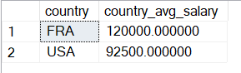
Task 4:
Highest and lowest average salary locations for senior-level employees in
2023:
Task: Identify which countries pay senior-level (SE) employees the highest and
lowest average salaries.
Hint: Filter the data by experience_level = SE and work_year = 2023. Group by
company_location and use aggregate functions to find the max and min
values. -- Combine both queries using a derived table
Ans:
select top 1 company_location, avg_salary as highest_avg_salary from
( select company_location, avg(salary) as avg_salary from WorkforceIncome
where work_year = 2023 AND experience_level = 'SE' group by company_location
) as SalaryByLocation
order by avg_salary desc;
select top 1 company_location, avg_salary as lowest_avg_salary
from ( select company_location, avg(salary) as avg_salary from WorkforceIncome
where work_year = 2023 and experience_level = 'SE' group by
company_location ) as SalaryByLocation
order by avg_salary asc;
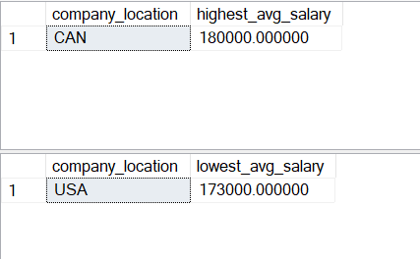
Task 5:
Salary growth rates by job title:
Task: Calculate the percentage increase in salaries for various job titles
between two years (e.g., 2023 and 2024).
Hint: Use the formula for percentage increase and compare the salary values
between the two years. This involves calculating the difference in salary
divided by the original salary.
Ans:
with SalaryByYear as ( select job_title, work_year, avg(salary) as avg_salary
from WorkforceIncome
where work_year in (2023, 2024)
group by job_title, work_year)
Select s2.job_title, ((s2.avg_salary - s1.avg_salary) / s1.avg_salary) * 100
as salary_growth_pct from SalaryByYear s1
join SalaryByYear s2 on s1.job_title = s2.job_title and s1.work_year = 2023
and s2.work_year = 2024;

Task 6:
Top three countries with the highest salary growth for entry-level roles from
2020 to 2023:
Task: Find the countries with the most significant salary growth in entry
level positions.
Hint: Calculate the growth rate for each country and rank them. Ensure that
companies have more than 50 employees (HAVING clause for filtering based on
the employee count).
Ans:
WITH SalaryByYear AS (
SELECT
employee_residence AS country,
work_year,
AVG(salary_in_usd) AS avg_salary,
COUNT(*) AS employee_count
FROM
WorkforceIncome
WHERE
experience_level = 'EN'
AND work_year IN (2020, 2023)
GROUP BY
employee_residence, work_year
HAVING
COUNT(*) > 50
),
SalaryGrowth AS (
SELECT
s2023.country,
s2023.avg_salary AS avg_2023,
s2020.avg_salary AS avg_2020,
((s2023.avg_salary - s2020.avg_salary) / s2020.avg_salary) * 100 AS growth_rate
FROM
SalaryByYear s2023
JOIN SalaryByYear s2020
ON s2023.country = s2020.country
AND s2023.work_year = 2023
AND s2020.work_year = 2020
)
SELECT TOP 3
country,
avg_2020,
avg_2023,
growth_rate
FROM
SalaryGrowth
ORDER BY
growth_rate DESC;
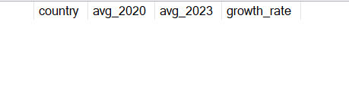
Task 7:
Updating remote work ratio for employees earning more than $90,000 in the US
and AU:
Task: Update the remote_ratio for employees based on their salary and
location.
Hint: Filter for employees with salary_in_usd > 90000 and employee_residence
in ('US', 'AU'). Then, apply an UPDATE statement to set their remote_ratio
to 100 for remote work
Ans:
update WorkforceIncome
set remote_ratio = 100
where salary_in_usd > 90000 and employee_residence in ('USA', 'AUS');
Task 8:
Salary updates based on percentage increases by level in 2024:
Task: Update the salaries for various experience levels (SE, MI, etc.)
according to predefined percentage increases.
Hint: Use a CASE statement to apply the percentage increases for each
experience level (e.g., SE = 22%, MI = 30%, etc.) in an UPDATE query.
Ans:
update WorkforceIncome
set salary = case experience_level
when 'SE' then salary * 1.22
when 'MI' then salary * 1.30
when 'EN' then salary * 1.15
when 'EX' then salary * 1.18
end
where work_year = 2024;
Task 9:
Year with the highest average salary for each job title:
Task: Identify which year had the highest average salary for each job title.
Hint: Group by job_title and use an aggregate function to calculate the
average salary for each year. Then, use a subquery or MAX() to get the
highest value.
Ans:
with AvgSalary as ( select job_title, work_year, avg(salary) as avg_salary
from WorkforceIncome group by job_title, work_year)
select job_title, work_year, avg_salary from AvgSalary a
where avg_salary = (select max(avg_salary) from AvgSalary where job_title =
a.job_title);
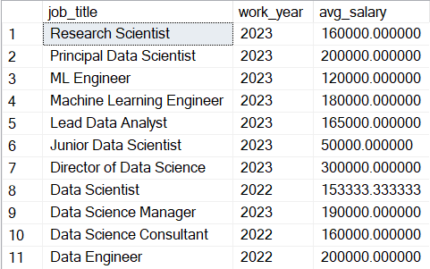
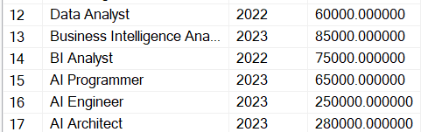
Task 10:
Percentage of employment types for different job titles:
Task: Calculate the percentage of full-time and part-time employees for each
job title.
Hint: Use a PIVOT style query to calculate the percentage distribution of
employment types (employment_type) for each job_title. You'll need to group
by job titles and use conditional aggregates to calculate percentages.
Ans:
SELECT
job_title,
ROUND(
100.0 * SUM(CASE WHEN employment_type = 'FT' THEN 1 ELSE 0 END) / COUNT(*),
2
) AS FT_Percentage,
ROUND(
100.0 * SUM(CASE WHEN employment_type = 'PT' THEN 1 ELSE 0 END) / COUNT(*),
2
) AS PT_Percentage
FROM
WorkforceIncome
GROUP BY
job_title
ORDER BY
job_title;
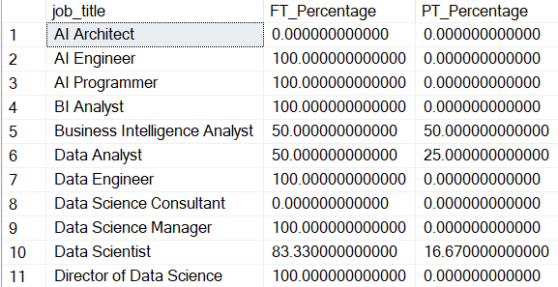
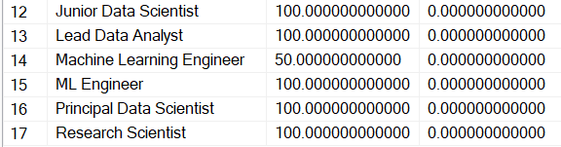
Task 11:
COUNTRIES OFFERING FULL REMOTE WORK FOR MANAGERS WITH SALARIES OVER $90,000:
TASK: FIND COUNTRIES WHERE MANAGERS EARN MORE THAN $90,000 AND WORK FULLY
REMOTELY.
HINT: FILTER THE DATA FOR JOB_TITLE CONTAINING 'MANAGER', SALARY_IN_USD >
90000, AND REMOTE_RATIO = 100. THEN, GROUP BY EMPLOYEE_RESIDENCE.
Ans:
select employee_residence as country, count(*) as manager_count from
WorkforceIncome
where job_title like '%Manager%' and salary_in_usd > 90000 and remote_ratio =
100
group by employee_residence;
Task 12:
Top 5 countries with the most large companies:
Task: Identify which countries have the highest number of large companies.
Hint: Filter the data for company_size = L and group by company_location. Use
COUNT() to rank the top 5.
Ans:
SELECT TOP 5
company_location AS country,
COUNT(*) AS large_company_count
FROM
WorkforceIncome
WHERE
company_size = 'L'
GROUP BY
company_location
ORDER BY
large_company_count DESC;
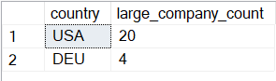
Task 13:
Percentage of employees with fully remote roles earning more than $100,000:
Task: Calculate the percentage of fully remote employees earning more than
$100,000.
Hint: Filter by remote_ratio = 100 and salary_in_usd > 100000, and then
calculate the percentage against the total number of employees.
Ans:
SELECT
ROUND(
100.0 * COUNT(CASE WHEN remote_ratio = 100 AND salary_in_usd > 100000 THEN 1 END)
/ COUNT(*),
2
) AS Percentage_Remote_HighEarners
FROM
WorkforceIncome;
Task 14:
Locations where entry-level average salaries exceed market average for entry
level:
Task: Identify locations where entry-level salaries surpass the market
average. Hint: Calculate the overall market average salary for entry-level
roles and compare it with location-wise averages.
Ans:
SELECT
employee_residence AS country,
ROUND(AVG(salary_in_usd), 2) AS avg_entry_salary
FROM
WorkforceIncome
WHERE
experience_level = 'EN'
GROUP BY
employee_residence
HAVING
AVG(salary_in_usd) > (
SELECT
AVG(salary_in_usd)
FROM
WorkforceIncome
WHERE
experience_level = 'EN'
)
ORDER BY
avg_entry_salary DESC;
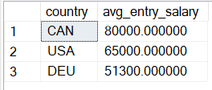
Task 15:
Countries paying the maximum average salary for each job title:
Task: For each job title, identify which country pays the highest average
salary.
Hint: Group by job_title and employee_residence, and use MAX(salary_in_usd) to
find the highest-paying country.
Ans:
WITH AvgSalaries AS (
SELECT
job_title,
employee_residence AS country,
ROUND(AVG(salary_in_usd), 2) AS avg_salary,
RANK() OVER (PARTITION BY job_title ORDER BY AVG(salary_in_usd) DESC) AS rank_salary
FROM
WorkforceIncome
GROUP BY
job_title, employee_residence
)
SELECT
job_title,
country,
avg_salary
FROM
AvgSalaries
WHERE
rank_salary = 1
ORDER BY
job_title;
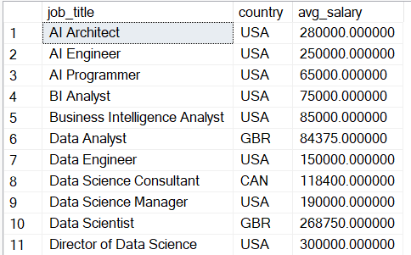
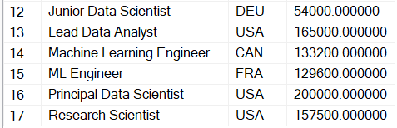
Task 16:
Countries with sustained salary growth over three years:
Task: Identify countries with consistent salary growth over the past three
years.
Hint: For countries with salary data for three years (e.g., 2021, 2022, 2023),
calculate the salary growth trend and identify those with continuous
growth.
Ans:
with SalaryTrend as ( select employee_residence,
work_year, avg(salary_in_usd)
as avg_salary from WorkforceIncome
where work_year between 2021 and 2023
group by employee_residence, work_year)
select employee_residence from SalaryTrend t1
where exists (select 1 from SalaryTrend t2 where t2.employee_residence =
t1.employee_residence and t2.work_year = 2022 and t2.avg_salary > (select
avg_salary from SalaryTrend where employee_residence = t1.employee_residence
and work_year = 2021))
and exists (select 1 from SalaryTrend t3 where t3.employee_residence =
t1.employee_residence and t3.work_year = 2023 and t3.avg_salary > (select
avg_salary from SalaryTrend where employee_residence = t1.employee_residence
and work_year = 2022))
group by employee_residence;

Task 17:
PERCENTAGE OF FULLY REMOTE WORK BY EXPERIENCE LEVEL (2021 VS 2024):
TASK: COMPARE THE ADOPTION OF FULLY REMOTE WORK ACROSS EXPERIENCE LEVELS
BETWEEN 2021 AND 2024.
HINT: CALCULATE THE PERCENTAGE OF EMPLOYEES WITH REMOTE_RATIO = 100 FOR BOTH
YEARS, GROUPED BY EXPERIENCE_LEVEL.
Ans:
with RemotePct as ( select work_year, experience_level, 100.0 * sum(case when
remote_ratio = 100 then 1 else 0 end) / count(*) as pct_fully_remote from
WorkforceIncome
where work_year in (2021, 2024)
group by work_year, experience_level)
select * from RemotePct
order by experience_level, work_year;

Task 18:
Average salary increase percentage by experience level and job title (2023 to
2024):
Task: Calculate the average salary increase for each experience level and job
title.
Hint: Use the salary data for 2023 and 2024 to compute the percentage increase
for each combination of experience level and job title.
Ans:
WITH SalaryByYear AS (
SELECT
experience_level,
job_title,
work_year,
AVG(salary_in_usd) AS avg_salary
FROM
WorkforceIncome
WHERE
work_year IN (2023, 2024)
GROUP BY
experience_level, job_title, work_year
),
SalaryChange AS (
SELECT
s2023.experience_level,
s2023.job_title,
s2023.avg_salary AS avg_salary_2023,
s2024.avg_salary AS avg_salary_2024,
ROUND(
((s2024.avg_salary - s2023.avg_salary) / s2023.avg_salary) * 100, 2
) AS avg_salary_increase_pct
FROM
SalaryByYear s2023
JOIN SalaryByYear s2024
ON s2023.experience_level = s2024.experience_level
AND s2023.job_title = s2024.job_title
AND s2023.work_year = 2023
AND s2024.work_year = 2024
)
SELECT
experience_level,
job_title,
avg_salary_2023,
avg_salary_2024,
avg_salary_increase_pct
FROM
SalaryChange
ORDER BY
experience_level, job_title;

Task 19:
Role-based access control for employees based on experience level:
Task: Implement security to restrict access based on an employee's experience
level.
Hint: Use conditional queries and access control mechanisms, ensuring
employees can only access records relevant to their experience level.
Ans:
CREATE TABLE ExperienceAccessControl (
login_name SYSNAME PRIMARY KEY,
allowed_experience_level CHAR(2)
);
INSERT INTO ExperienceAccessControl VALUES ('EN_User', 'EN');
INSERT INTO ExperienceAccessControl VALUES ('MI_User', 'MI');
INSERT INTO ExperienceAccessControl VALUES ('SE_User', 'SE');
INSERT INTO ExperienceAccessControl VALUES ('EX_User', 'EX');

DECLARE @CurrentUser SYSNAME = 'SE_User';

SELECT *
FROM WorkforceIncome
WHERE experience_level = (
SELECT TOP 1 allowed_experience_level
FROM ExperienceAccessControl
WHERE login_name = @CurrentUser
);
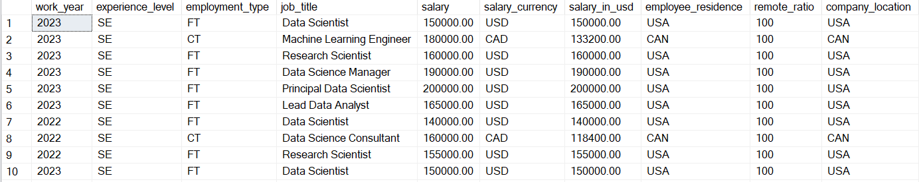 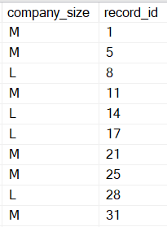
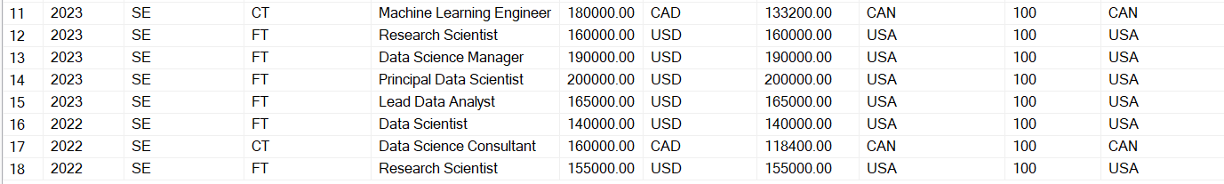 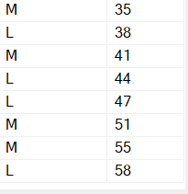
Task 20:
Guiding clients in switching domains based on salary insights:
Task: Based on an employee's data (experience, job title, location), suggest
new domains they can transition to, based on salary trends.
Hint: Analyze salary trends for various roles and provide recommendations for
transitions that offer higher salaries or better opportunities.
Ans:
with AvgSalary as ( select job_title, experience_level, employee_residence,
avg(salary_in_usd) as avg_salary from WorkforceIncome group by job_title,
experience_level, employee_residence)
select experience_level, employee_residence, string_agg(job_title, ', ') as
recommended_roles from AvgSalary
where avg_salary > (select avg(salary_in_usd) from WorkforceIncome where
experience_level = AvgSalary.experience_level and employee_residence =
AvgSalary.employee_residence);
group by experience_level, employee_residence;
